Evacuation video link:

1. <https://www.youtube.com/watch?v=7p1m4hB6PKA&t=197s>
2. <https://www.youtube.com/watch?v=sBfm1trLLFE>
3. youtube.com/watch?v=v1Ll7oLiHLA
4. <https://www.youtube.com/watch?v=4Vmc3ZwW-qM>

Accessibilty:

1. A wheelchair ramp is an [inclined plane](https://en.wikipedia.org/wiki/Inclined_plane) installed in addition to or instead of [stairs](https://en.wikipedia.org/wiki/Stairway). Ramps permit [wheelchair](https://en.wikipedia.org/wiki/Wheelchair) users, as well as people pushing [strollers](https://en.wikipedia.org/wiki/Stroller), [carts](https://en.wikipedia.org/wiki/Cart), or other wheeled objects, to more easily access a building.

1. Scooter : [Disability scooter](http://ilsau.com.au/department/mobilityscooters/)is a mobility aid resembling a wheelchair but built like a motor scooter. It is usually known as an electric scooter or power-operated mobility scooter.

A [disability scooter](http://ilsau.com.au/department/mobilityscooters/) is ideal for people with precise or whole-body disabling conditions such as some form of arthritis, obesity, coronary or lung issues but still able to stand and walk a few steps, control the steering tiller and sit straight without body support.

1. Stairlifts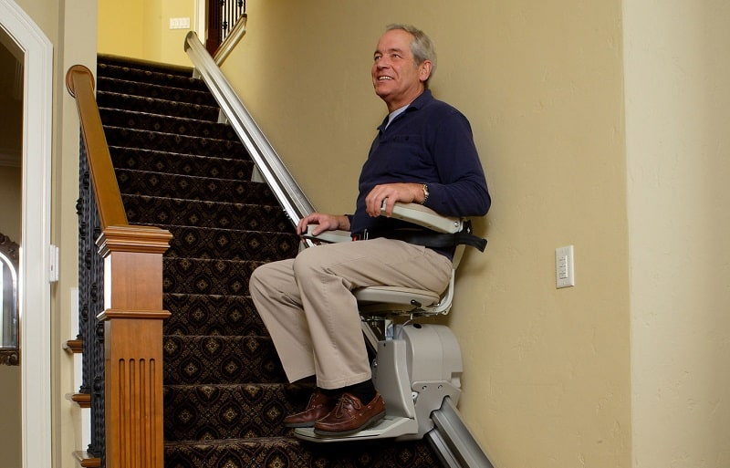

**The wheelchair stair platform lift is the ideal choice for homes or commercial areas where disabled access along a stairway is required among wheelchair users or those who are less mobile, thereby allowing easy access up and down stairs on their own.** Platform stairlifts provide an accessibility solution for people in wheelchairs or for those who have difficulty climbing stairs. These inclined platform [wheelchair lifts](https://easylivingplatformlifts.com.au/wheelchair-stair-lifts/)are custom designed and manufactured for each individual project, and are perfect for indoor and outdoor applications.

1. Automated doors

This type of **automatic door** can be opened without performing any actions, so **disabled** people do not have to stop moving to pass through the doorway. Thanks to the system's proximity sensors, people can move fluidly and without having to stop to push the handle.

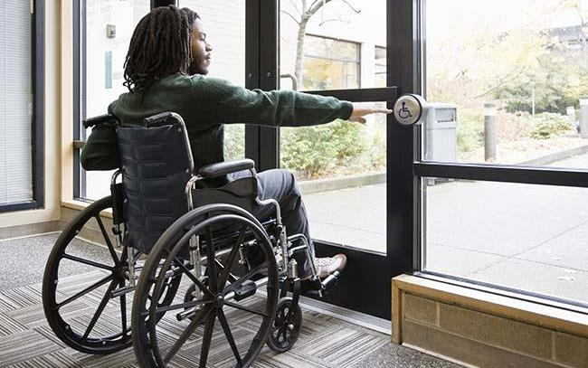

1. Height-adjustable work stations

**Adjustable height desks** allow the user to select a **working** position that is ideal for their body. Employees who alternate between a sitting and standing positions will have more energy, experience reduced fatigue levels, and reduce their risk of injury caused by **working** in one body position too long.

1. Vehicle modifications (work-related)

A vehicle modification is a change or addition to your vehicle. Modifications can be minor (like a grab bar, or a simple steering aid that’s attached to the steering wheel) or major (like a ramp or alternative steering/braking systems). Common vehicle modifications to help driving with a disability include:

* steering aids
* left-foot accelerators
* custom hand controls
* extended or additional mirrors.

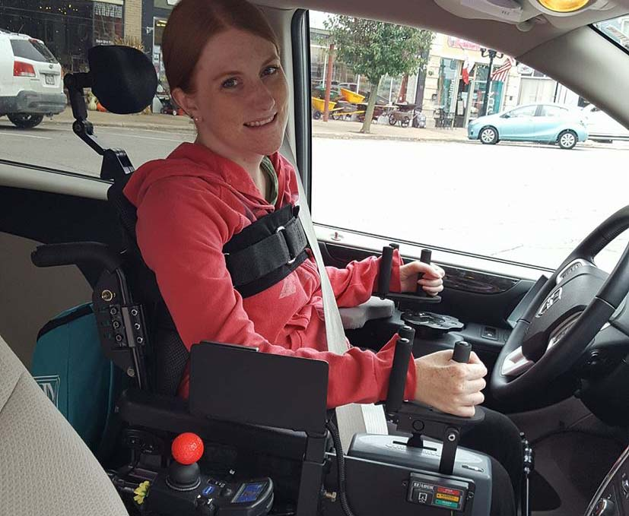

<https://tech4impact.com/articlesandvideos/putting-a-stop-to-accessible-parking-abuse-with-the-parking-mobility-app>

1. Accessible toilet

An **accessible toilet** is designed to accommodate people with [physical disabilities](https://en.wikipedia.org/wiki/Physical_disability). [Persons with reduced mobility](https://en.wikipedia.org/wiki/Persons_with_reduced_mobility) find them useful, as do those with weak legs, as a higher toilet bowl makes it easier for them to stand up. Additional measures to add accessibility are providing more space and [grab bars](https://en.wikipedia.org/wiki/Grab_bar) to ease transfer to and from the [toilet seat](https://en.wikipedia.org/wiki/Toilet_seat), and including enough room for a [caregiver](https://en.wikipedia.org/wiki/Caregiver) if necessary. Some countries have requirements concerning the [accessibility](https://en.wikipedia.org/wiki/Accessibility) of [public toilets](https://en.wikipedia.org/wiki/Public_toilet). [Toilets in private homes](https://en.wikipedia.org/wiki/Toilet_(room)) can be modified ([retrofitted](https://en.wikipedia.org/wiki/Retrofit)) to increase accessibility.

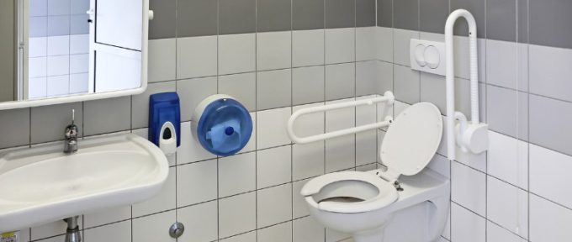

1. Accessible lift

Platform stairlifts provide an accessibility solution for people in wheelchairs or for those who have difficulty climbing stairs. These inclined platform [wheelchair lifts](https://easylivingplatformlifts.com.au/wheelchair-stair-lifts/) are custom designed and manufactured for each individual project, and are perfect for indoor and outdoor applications.

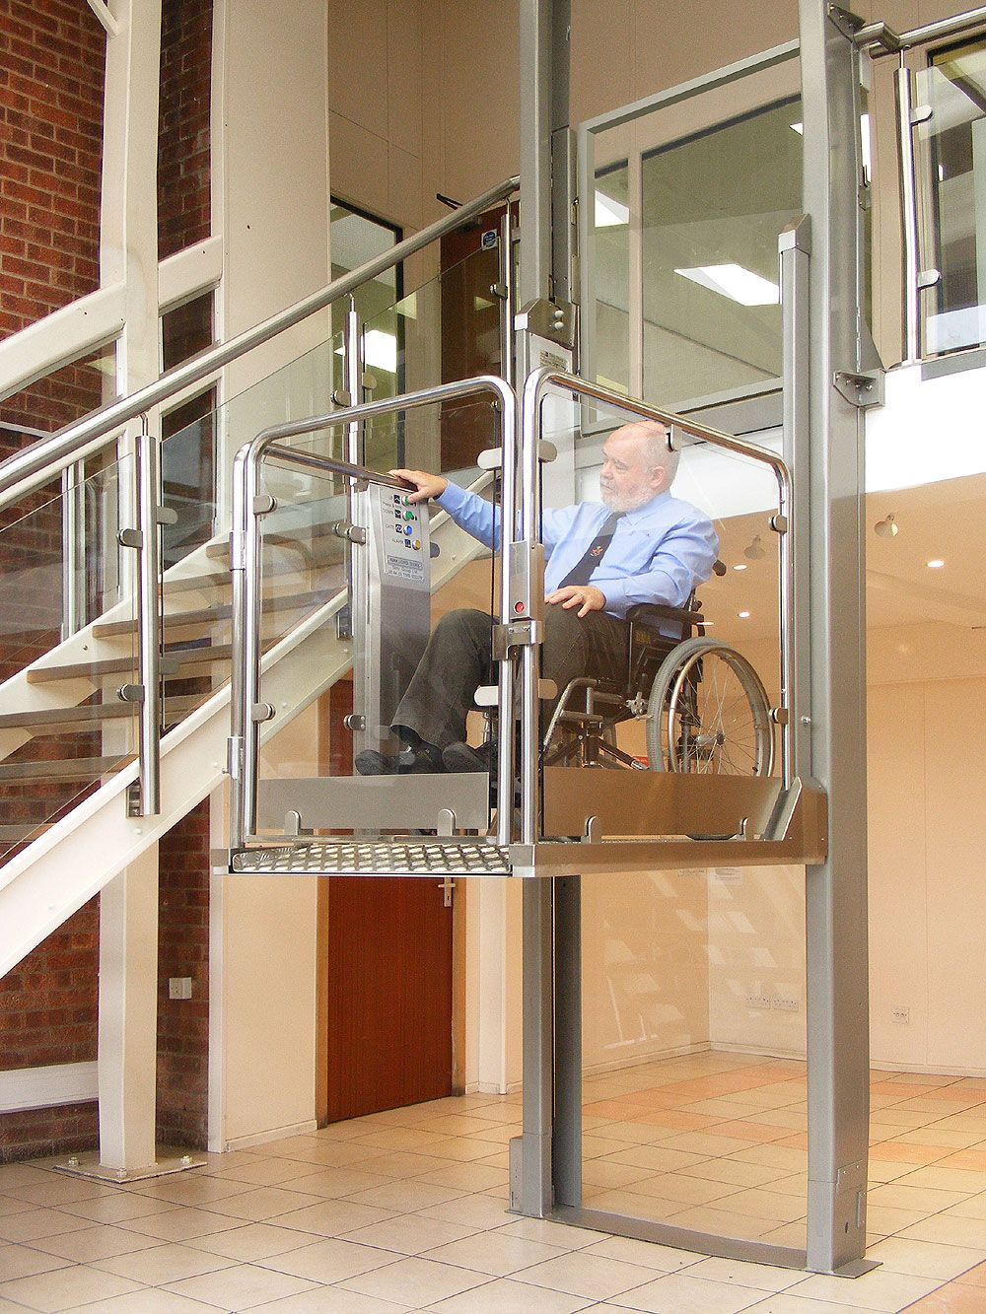

https://www.pinterest.co.uk/pin/10414642865057456/

1. Handrails

Having **handrails** installed in specific areas of your home can potentially prevent or significantly reduce the chances of an accident, such as a fall or slip, from occurring– as high-quality **grab rails** offer unmatched slip protection and stability, increasing safety and comfort for the end-user

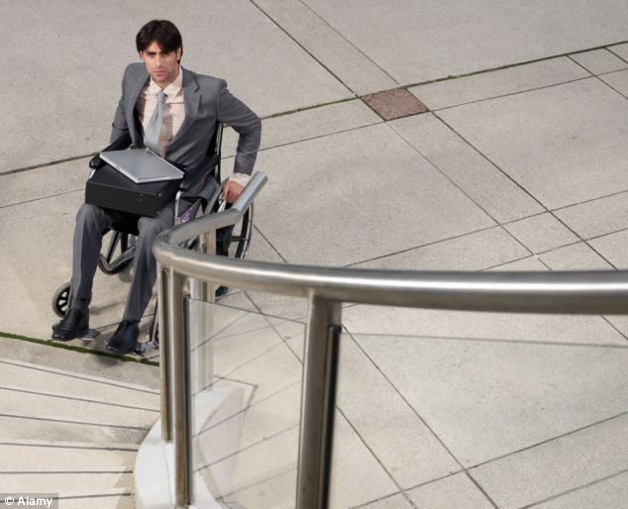

https://www.google.com/url?sa=i&url=https%3A%2F%2Fwww.dailymail.co.uk%2Fnews%2Farticle-2511608%2FThe-south-best-place-People-likely-struggle-disabilities-health-problems-live-north.html&psig=AOvVaw2iN2aXUIHIONhY5Db_TwXM&ust=1600341756479000&source=images&cd=vfe&ved=0CAIQjRxqFwoTCMCnjMbI7esCFQAAAAAdAAAAABAT

1. Accessible computer keyboards, mouses

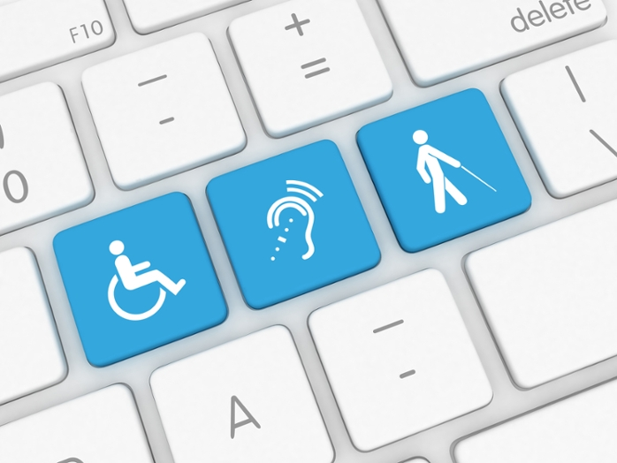

1. Adapted office furniture or equipment

Since we spend 8 hours a day 5 days a week at work, it is highly important to make your work space and desk as comfortable as possible. Workstations should be placed in a position that has adequate lighting and is close to an exit for easier access to the restrooms. Below are just a few [tips for adjusting office furniture](http://blog.jpofficeworkstations.com.au/2013/03/disability-friendly-workplaces-employer.html#.WAOr7uArLNN) and accessories to make them fit a disabled person’s needs:

* **Desk:**There are a [variety of styles for workstations](https://www.furniturewholesalers.com/office-furniture/desks-workstations.aspx)for the disabled. Finding the one to suite your needs is most important. Under the ADA, a disabled person has the right to have their desk adjusted to fit your needs. If you are in a wheelchair, a desk can be adjusted higher or if the desk is too high, you can ask for it to be moved lower.
* **Chair**: Make sure that the chair that you choose works with your desk and is comfortable. There are many disability friendly [ergonomic chairs](https://www.furniturewholesalers.com/office-furniture/chairs-seating.aspx) available including lumbar support chairs for those with back issues, adjustable arms that can go up or down depending on your height, tilted seats and easy roll or no roll for transferring in and out of a wheelchair.
* **Space:** Leave plenty of space between workstations or in cubicles for wheelchairs or mobility equipment to get in from all angles. Make sure there is enough room for turning a wheelchair in cubicles, in aisle ways, breakrooms and in hallways.
* **Storage:** Storage areas should be accessible for any user. You can organize your desk top with desk accessories that can be easily within reach. Cubicles could have built-in shelves that could be too high (or too low) for a disabled person. Ask to have the shelves adjusted to the level that fits your best. Have [filing cabinets](http://www.furniturewholesalers.com/office-furniture/filing-storage.aspx) with soft close drawers to avoid catching fingers and add shelf extenders so items can be accessed easier in the drawers.

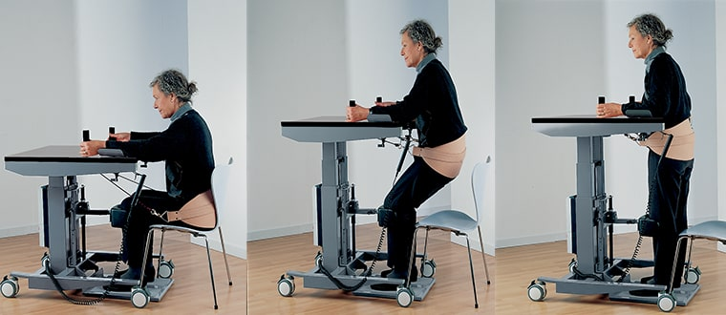

https://www.ameridisability.com/post/create-an-accessible-workspace-with-these-adaptive-items

Speech-recognition (speech-to-text) software

**Benefits** for **people with disabilities** may include improved access to the computer, increases in writing production, improvements in writing mechanics, increased independence, decreased anxiety around writing, and improvements in core reading and writing abilities.

